1- Deploy rhcsa1.exam.sample.com and rhcsa2.exam.sample.com to

network with the following information.

rhcsa1.exam.sample.com:

- IP address= A.A.A.85 (replace A.A.A with the network ID=PORTION

of your home network)

- Default Gateway = your home network gateway

- Subnet mask = 255.255.255.0

- DNS1 = 8.8.8.8

- DNS2 = 8.8.4.4

- Hostname= rhcsa1.exam.sample.com

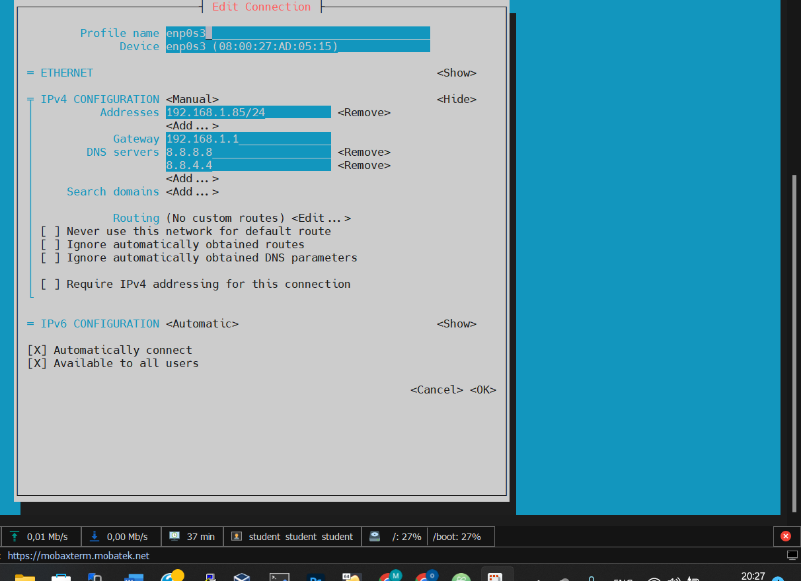

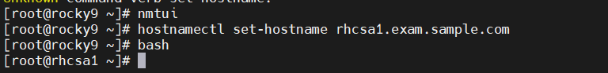

rhcsa2.exam.sample.com:

- IP address= A.A.A.90 (replace A.A.A with the network ID=PORTION

of your home network)

- Default Gateway = your home network gateway

- Subnet mask = 255.255.255.0

- DNS1 = 8.8.8.8

- DNS2 = 8.8.4.4

- Hostname= rhcsa2.exam.sample.com

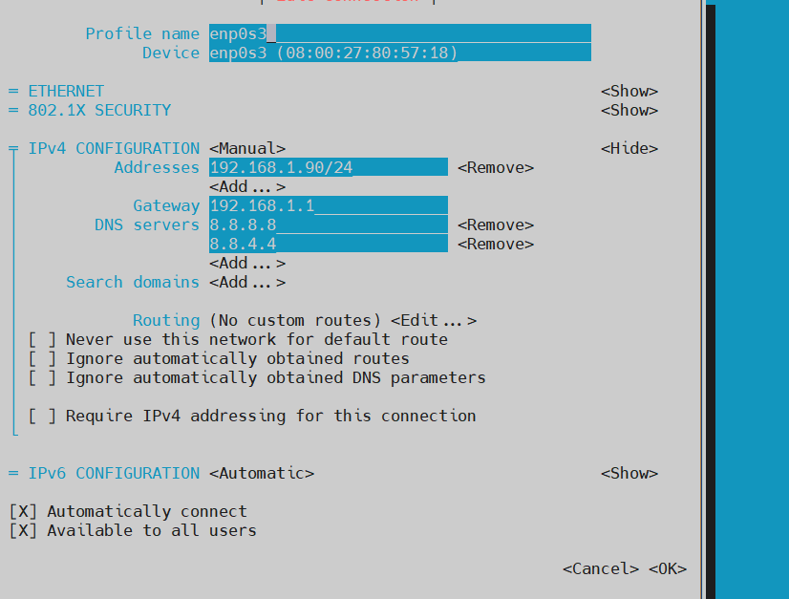

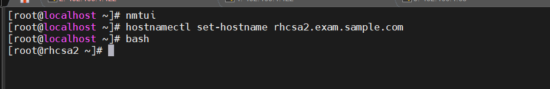

2- Configure yum repos on both servers to be able to install Packages

Alma 9 BaseOS:

baseurl=https://repo.almalinux.org/almalinux/$releasever/BaseOS/$basearch/os/

Alma 9 AppStream:

baseurl=https://repo.almalinux.org/almalinux/$releasever/AppStream/$basearch/os

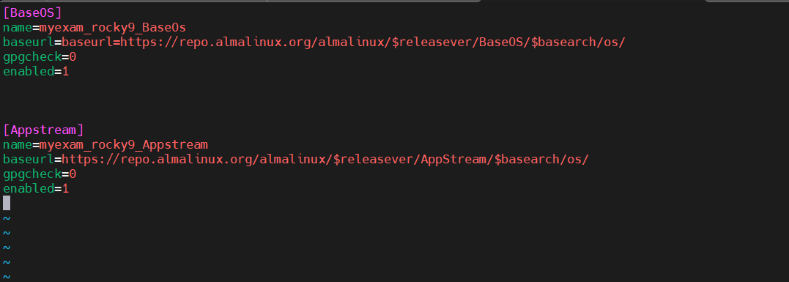

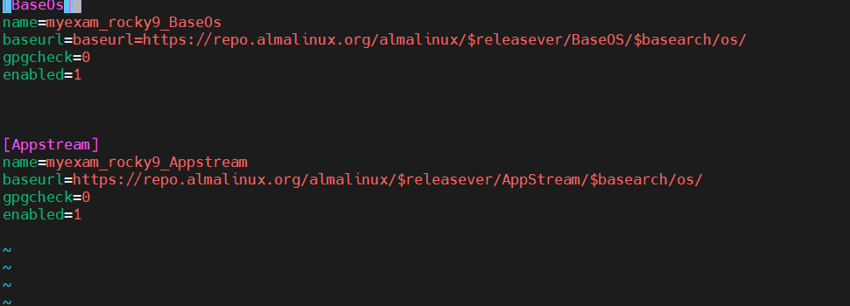

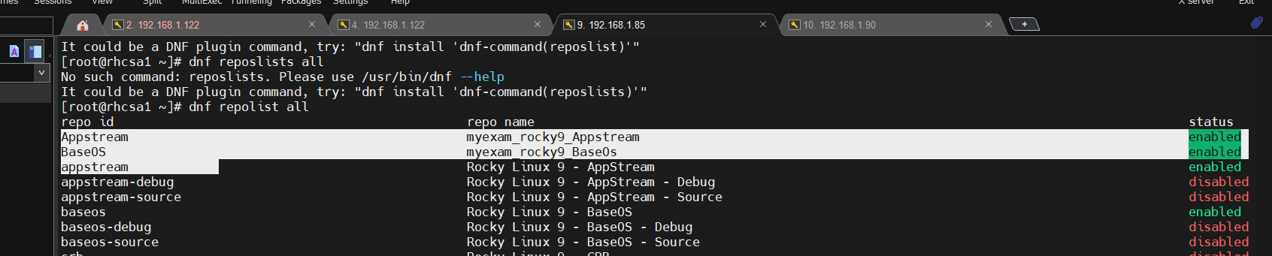

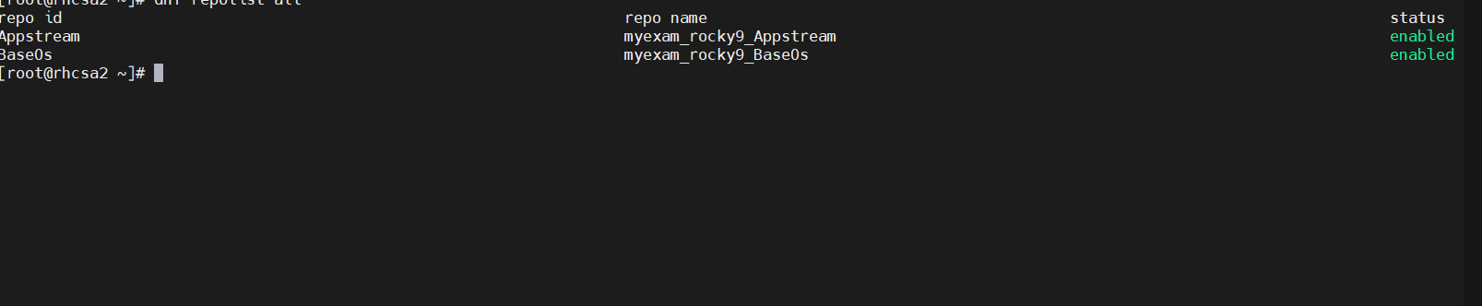

3- List all lines that have string “max” in /etc/systemd/journald.conf and dump

them into /var/max.txt file.

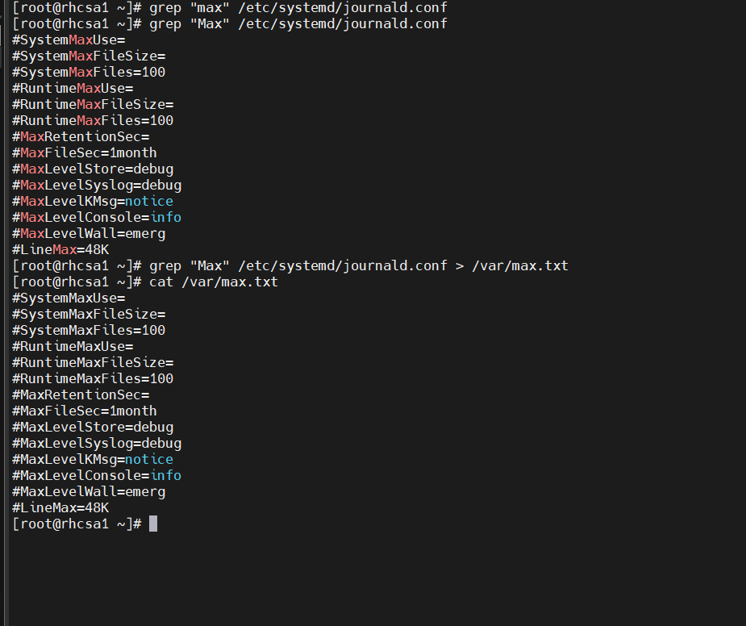4- Check the SELinux and make sure it is in enforcing mode.

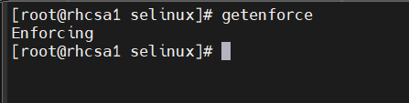

5- Troubleshoot and fix apache httpd web application issue and ensure that it is

browse-able using the server IP and display content “This is rhcsa exam

test”

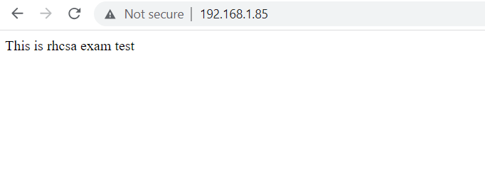

6- Find All Files in /etc (not subdirectories) that where modified more than 180

days ago.

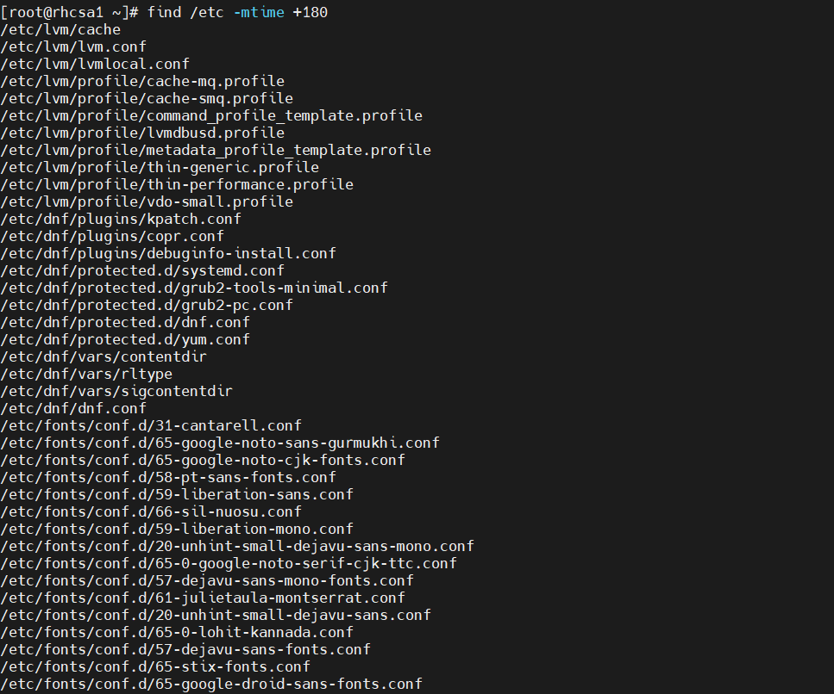

7- Create a group named &quot;supervisor&quot;

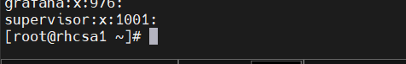

a- User “John” and “sams” should belong to “supervisor” group as a

secondary group

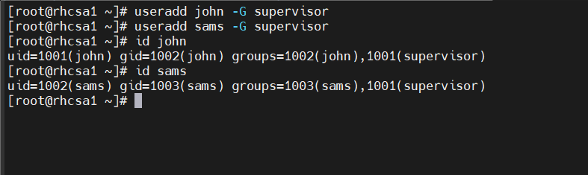

b- User “shawn” should have non-interactive shell and she should not be a

member of “supervisor” group

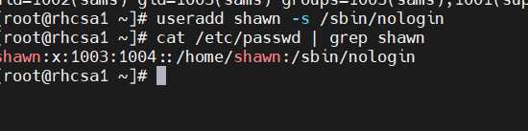

c- Password for all users created should be “california”.

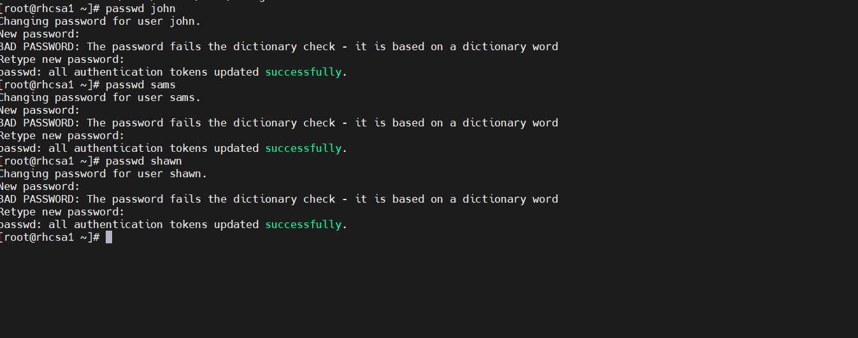

8- Create the Directory &quot;/var/master&quot; with the following characteristics.

a- Group ownership of “/var/master” should go to “supervisor” group.

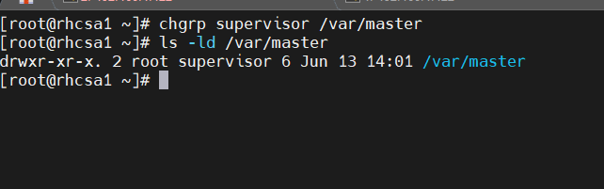

b- Members of “supervisor” group should be able to read write and

access /var/master.

c- Newest files create inside /var/master should get the same group

ownership as the directory.

d- All other users should have no access to the directory.

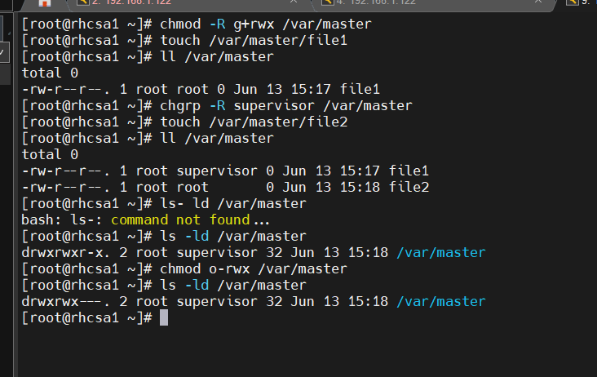

9- Archive /var/log to /tmp/log_archive.tgz using bzip2 compression.





10- Find all setuid files on the system and save the list

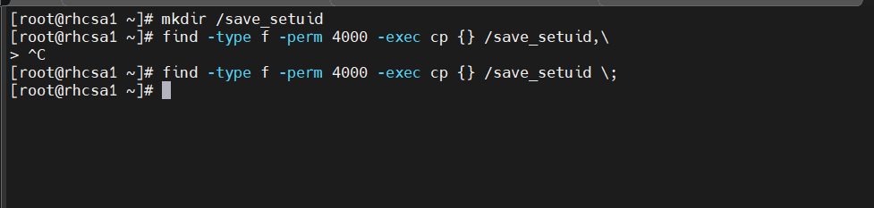

11- Find all log messages in /var/log/messages that contain &quot;ACPI&quot;, and

export them to a file called /root/log. Then archive all of /var/log and save it

to /tmp/log_archive1.tgz

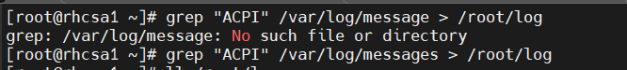

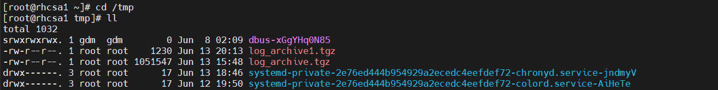

12- Write a script named backup.sh under /root which will search files

less than 2M from /usr and store it in /root/backup

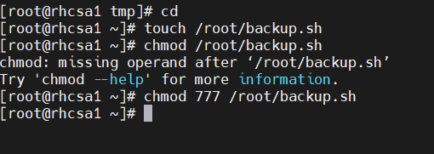

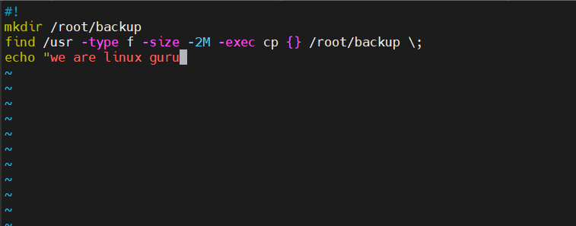

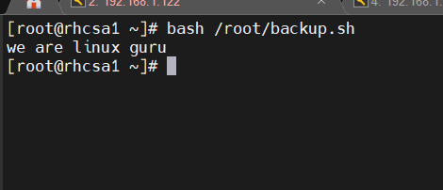

13- Install the Stratis software packages, start the Stratis service, and mark

it for autostart on subsequent system reboots

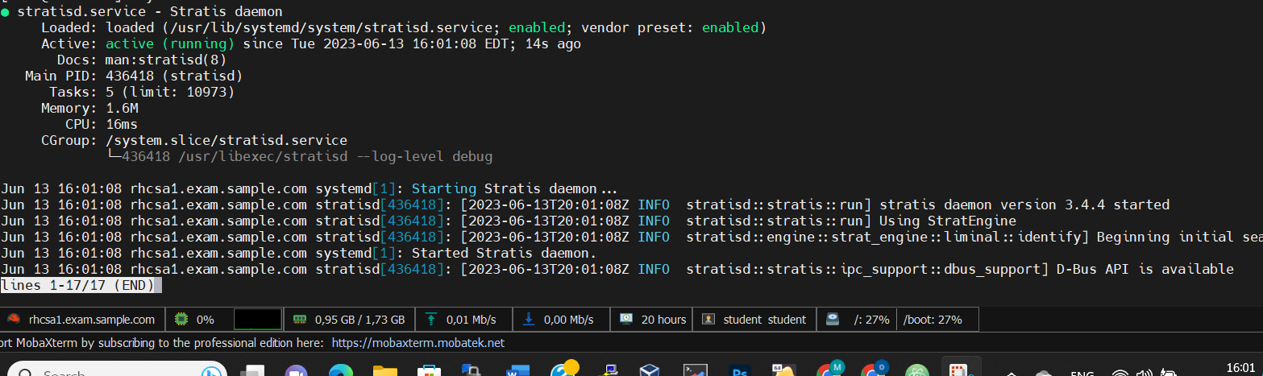

14- The user Alain must configure a cron job that run every day at 6:15pm

as himself and do the following: echo “This is Alain Job”

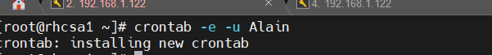

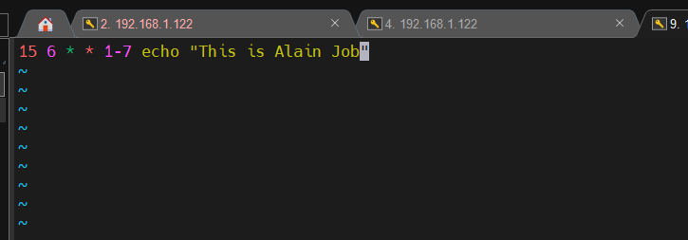

15- Create the archive file /root/local.tgz for /usr/local compressed

by gzip



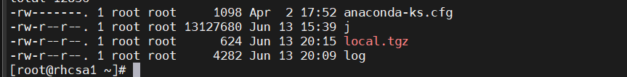

16- Create the user malick with uid 2333 with password &quot;california&quot;.

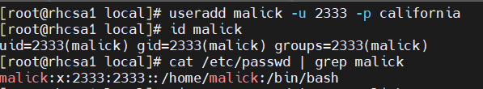



17- Configure the NTP service and sync the server time to the following

NTP server 1.amazon.pool.ntp.org



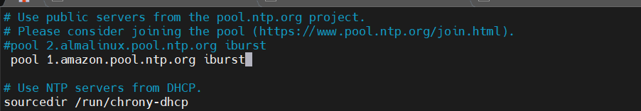

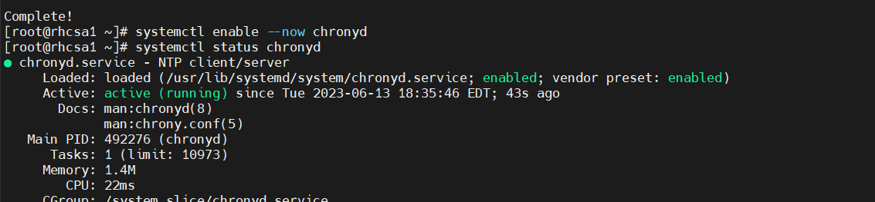

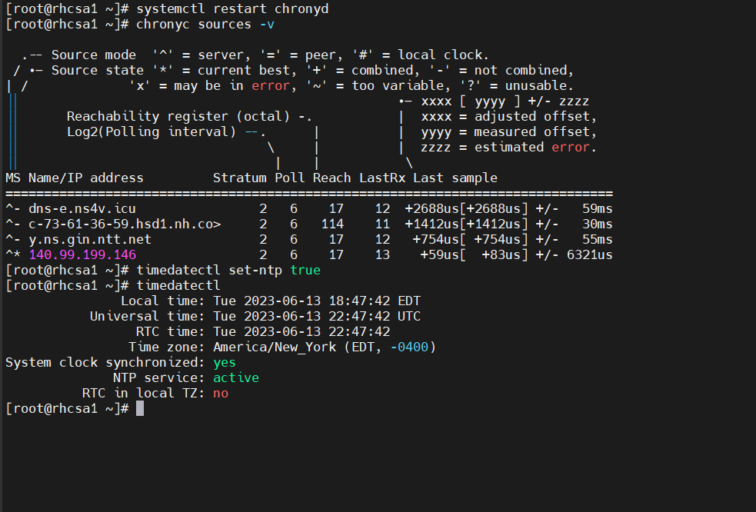

18- The user student must configure a cron job that run every two minutes

as himself the command “cat /etc/passwd”

19- Set your server to use the recommended tuned profile.

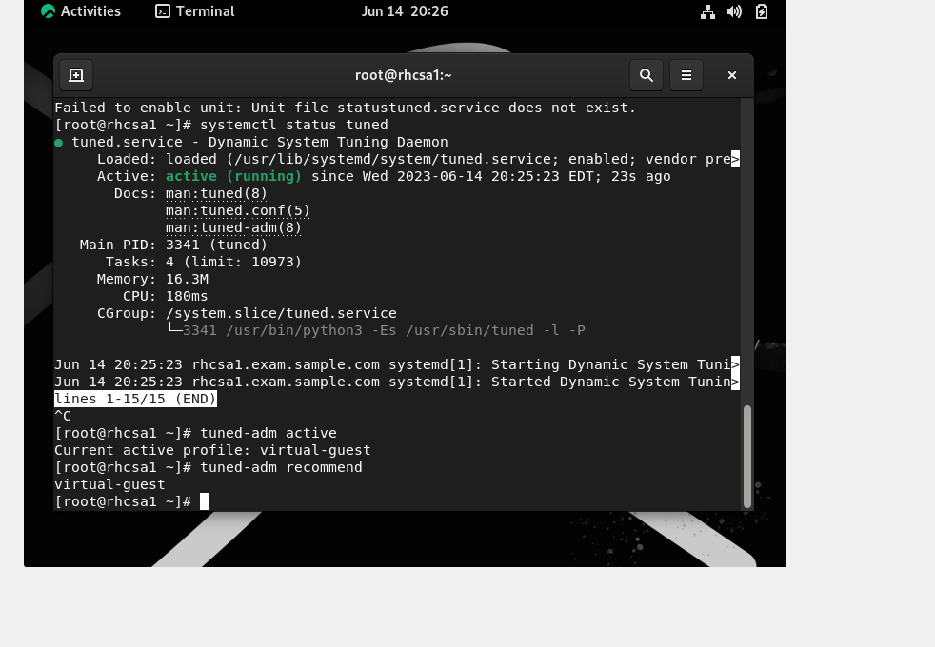

20- Find the files that are larger than 20M owned by root user and redirect

them to /var/findfiles.

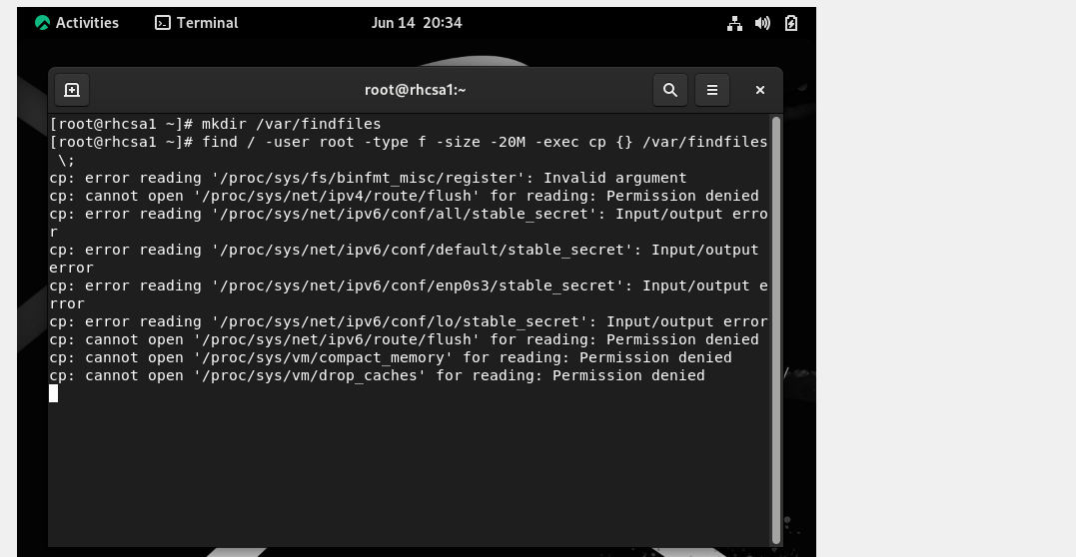

21- Find all files owned by Alain user and redirect them to /root/findfiles

directory.

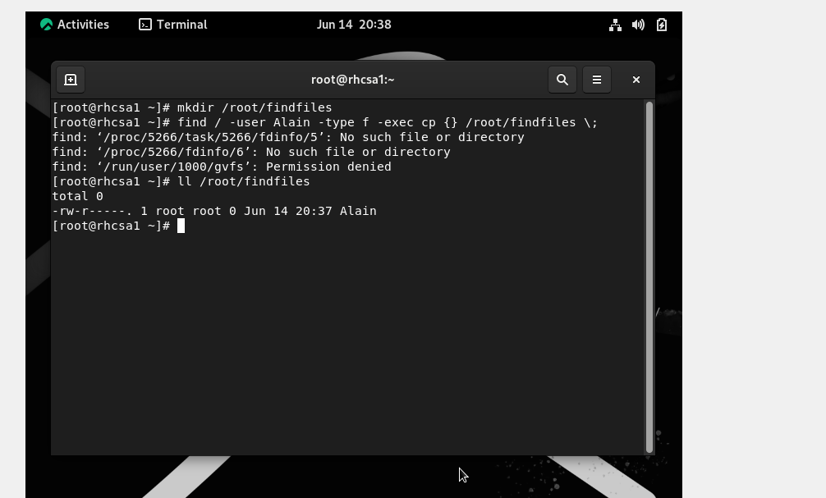

22- Update your system setting so that any future user created will have

account expiring in next 20 days.

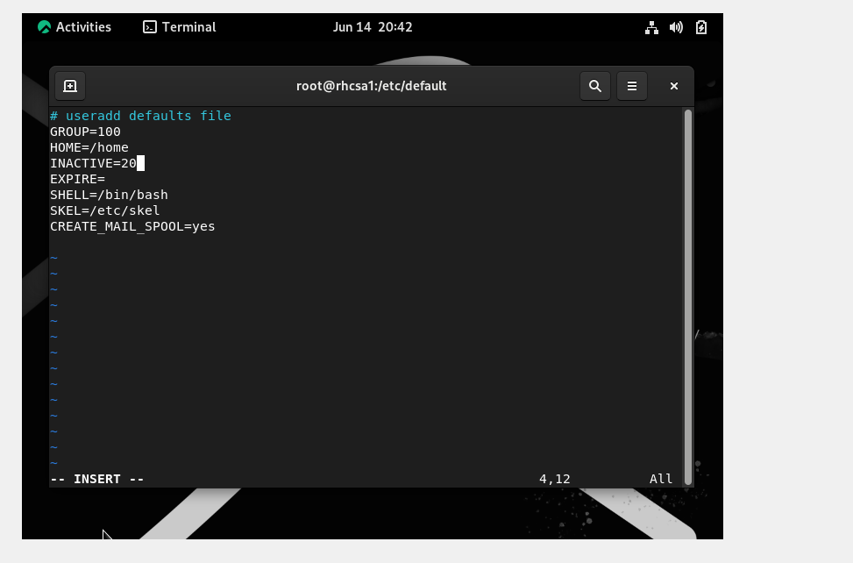

23- Create a logical volume with the name “LVo” by using 60PE’s from

the volume group “VGo”. Consider the PE size as “8MB”. Mount it on

/mnt/redhat8 with ext3 filesystem.

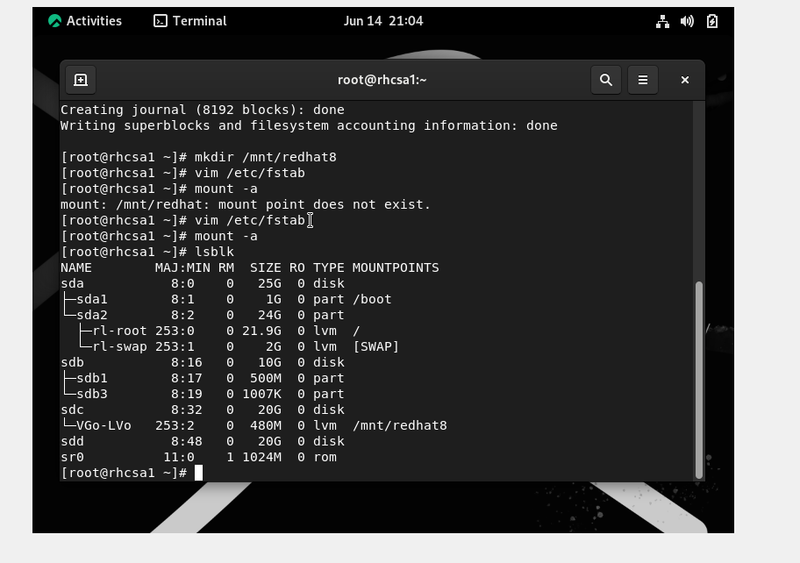

24- Resize /newlv file system so that it is 400MB. Any size in between

380 and 430

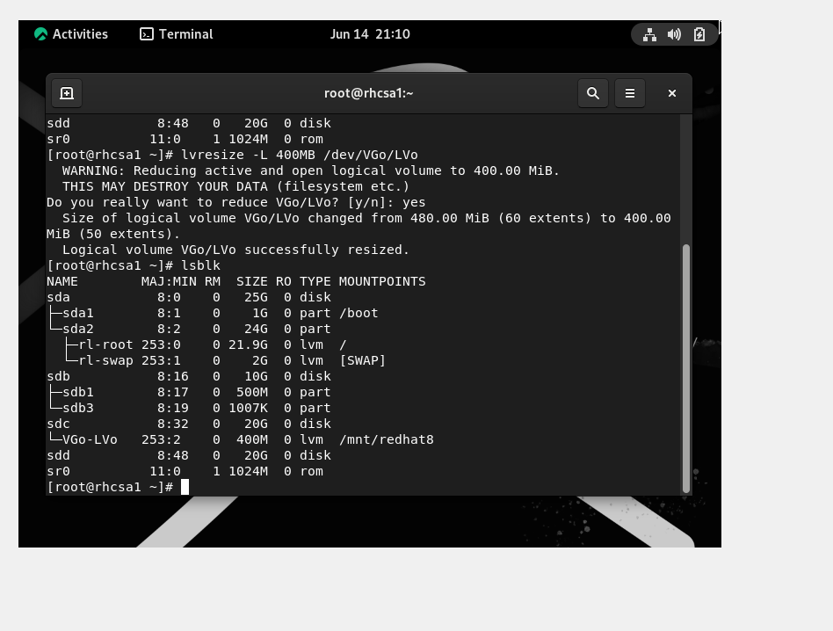

25- Create a 1G swap space. Make sure the current partition where the

swap is mounted is not altered.

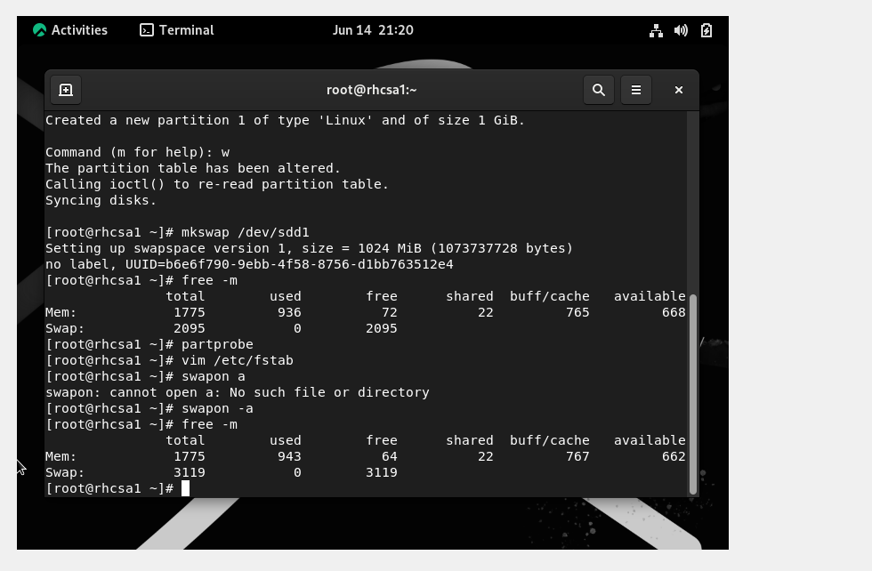

26- Add a new 10GiB virtual disk sdb to your virtual machine. On this

disk, add a VDO volume with a size of 30GiB and mount it persistently to

/mnt/vdo.